Name: Kaustav Ghosh

Reg no: 180905188

Section: CSE – C

Roll no 29

Q3.1

Request

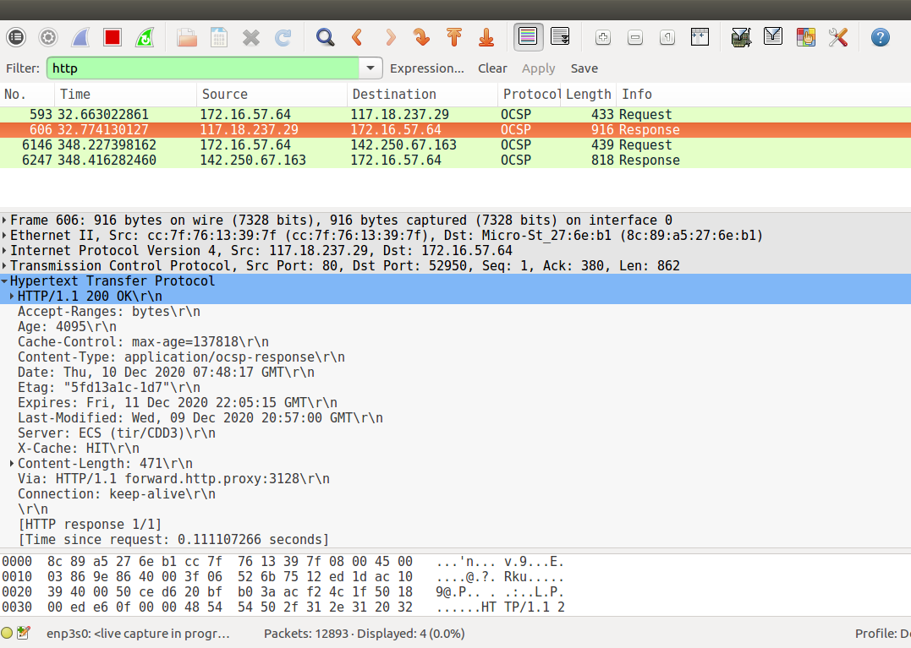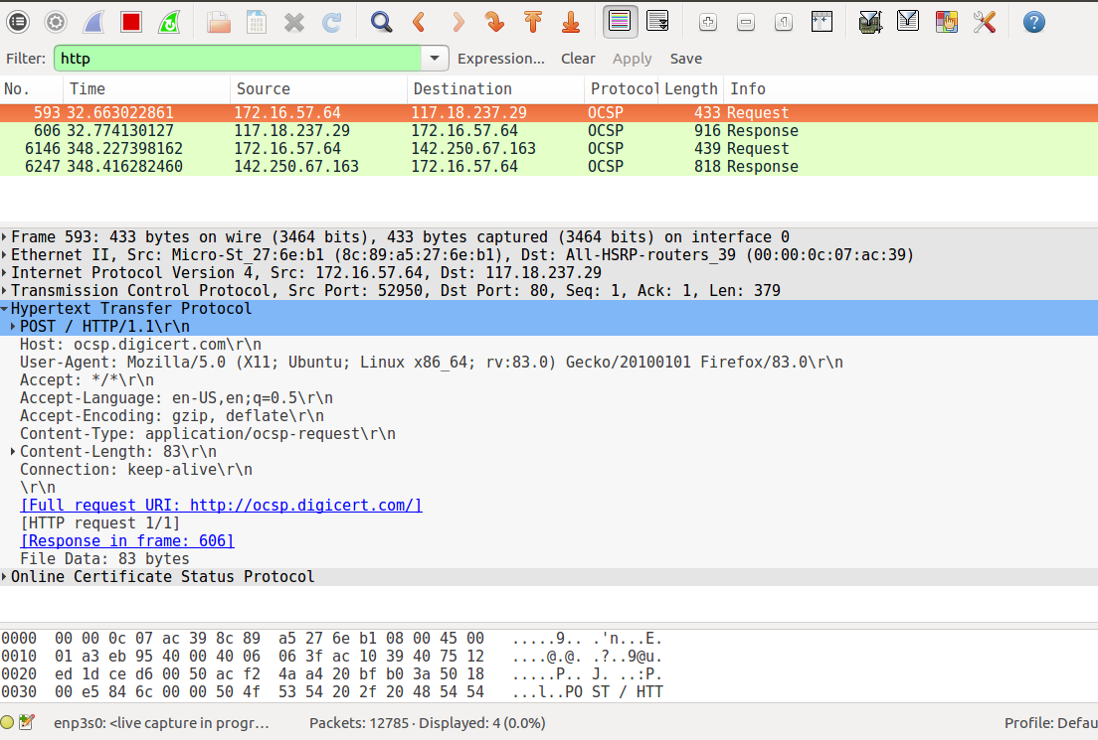

Response

Q3.2

request

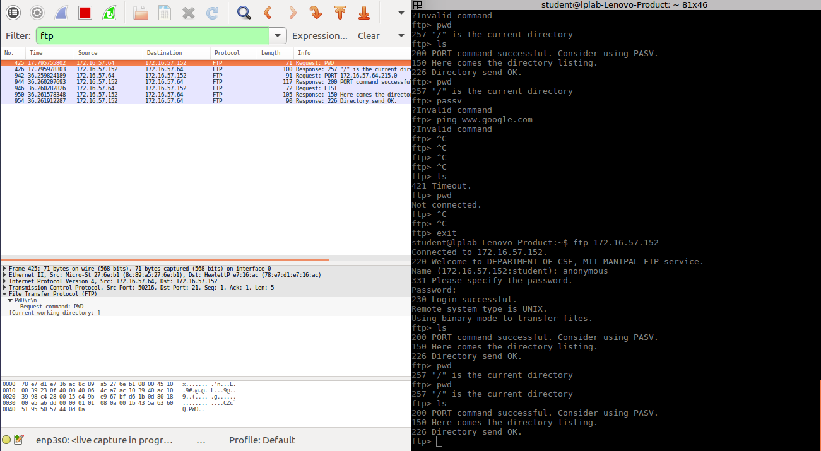

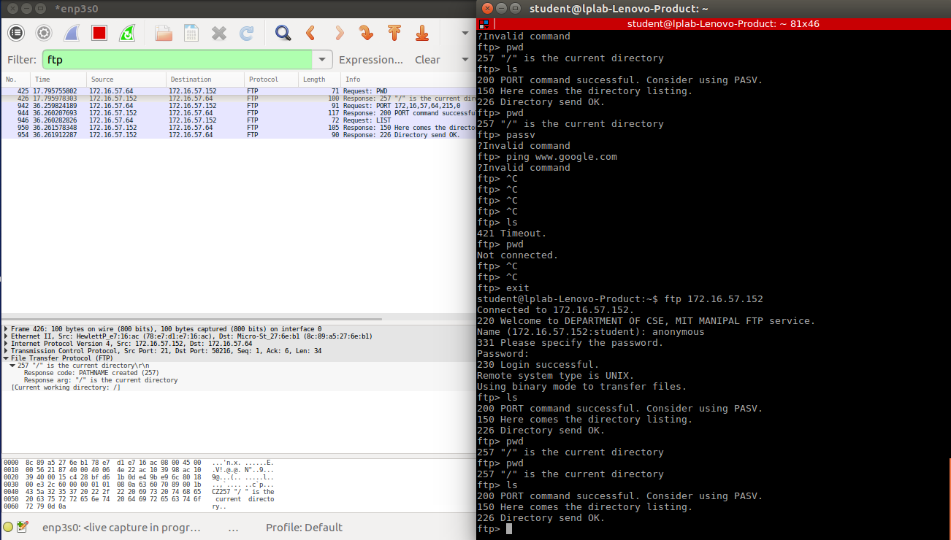 Response

Q 3.7

DNS

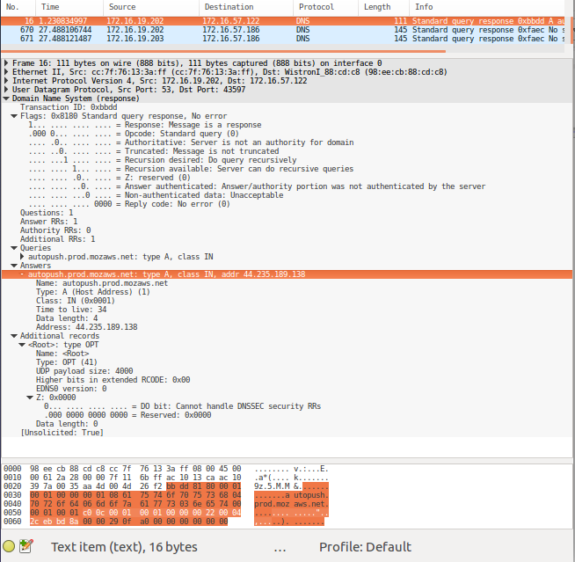

Q 4.1

4.1a

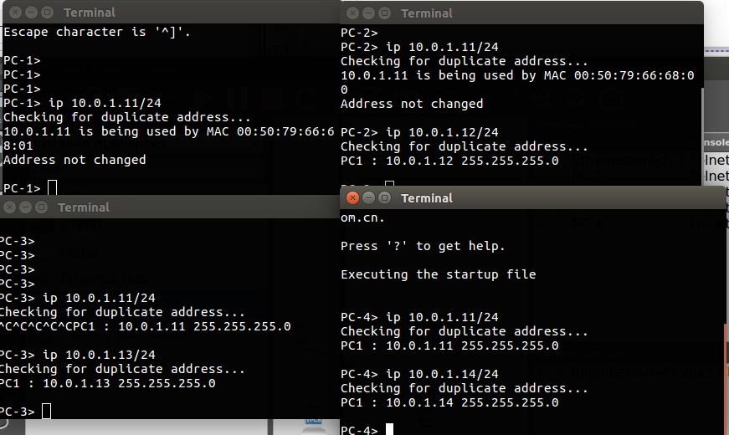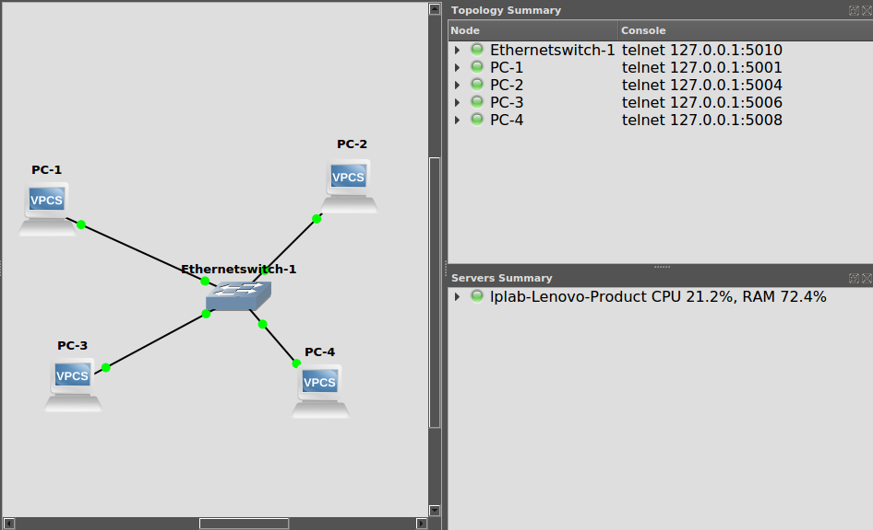network01_gns3_simulation

4.1 a

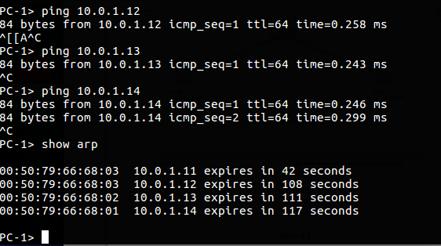

4.1b

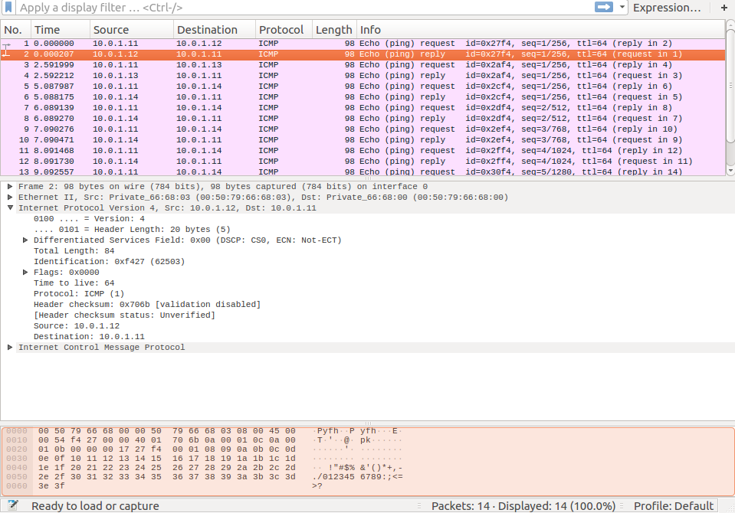

4.1 c



4.1d

MAC Addresses

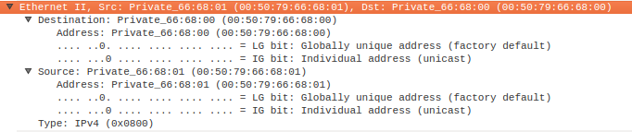

Showing ARP Table

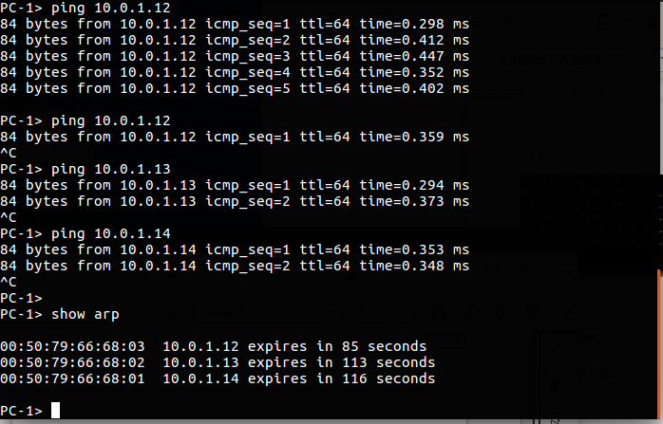

4.1e

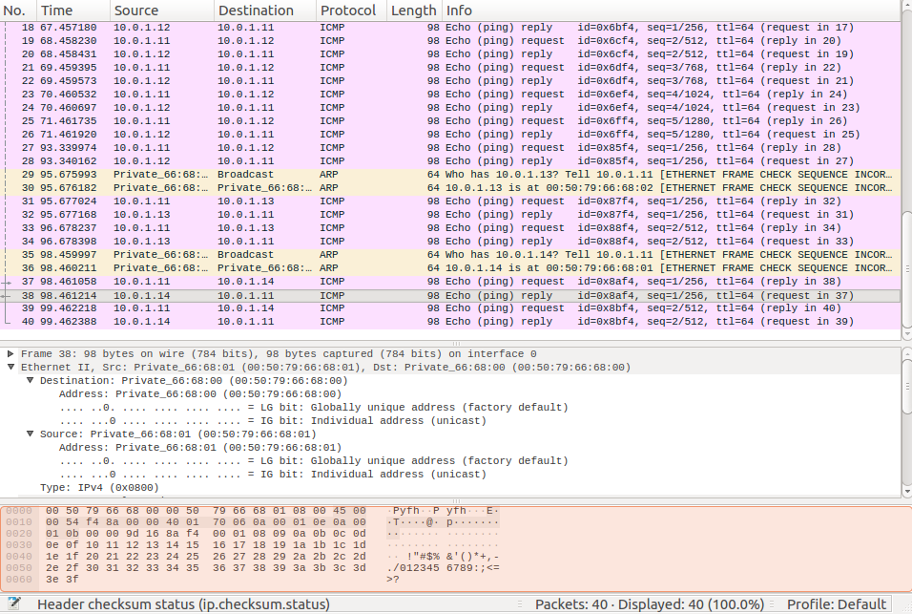

Exercises

1. What is the destination MAC address of an ARP Request packet?

Ans: It is the MAC address of the device to which the ARP Request packet is being sent

For example: Destination: Private_66:68:01 (00:50:79:66:68:01) for 10.0.0.4

2. What are the different Type Field values in the Ethernet headers that you observed?

Ans:

Ethernet II, Src: Private_66:68:02 (00:50:79:66:68:02), Dst: Private_66:68:00 (00:50:79:66:68:00)

Destination: Private_66:68:00 (00:50:79:66:68:00)

Address: Private_66:68:00 (00:50:79:66:68:00)

.... ..0. .... .... .... .... = LG bit: Globally unique address (factory default)

.... ...0 .... .... .... .... = IG bit: Individual address (unicast)

Source: Private_66:68:02 (00:50:79:66:68:02)

Address: Private_66:68:02 (00:50:79:66:68:02)

.... ..0. .... .... .... .... = LG bit: Globally unique address (factory default)

.... ...0 .... .... .... .... = IG bit: Individual address (unicast)

Type: IPv4 (0x0800)

3. Use the captured data to analyse the process in which ARP acquires the MAC

address for IP address10.0.1.12.

Ans: MAC Address: Private_66:68:03 (00:50:79:66:68:03)

4. Use your output data and ping results to explain what happened in each of the ping

commands.

Ans: When the pings were made to other devices , those devices showed up in the ARP table of the source computer

5. Which ping operations were successful, and which were unsuccessful? Why?

Ans: All pings wer successful.

Q 4.2

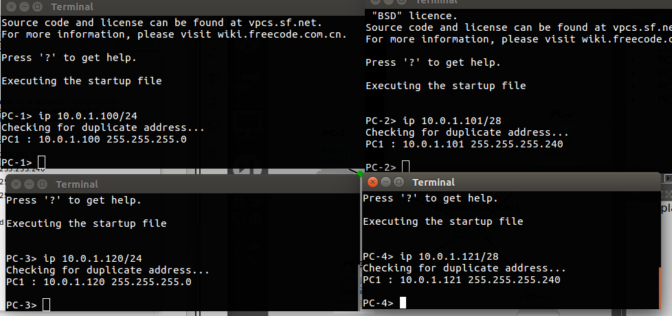

4.2a

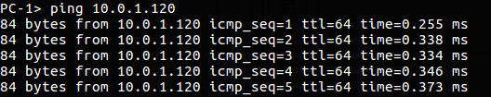

4.2b

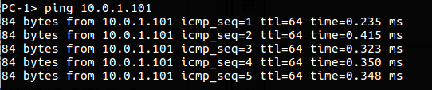

4.2 c

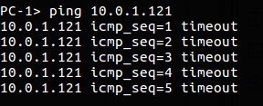

4.2d



4.2e



4.2f



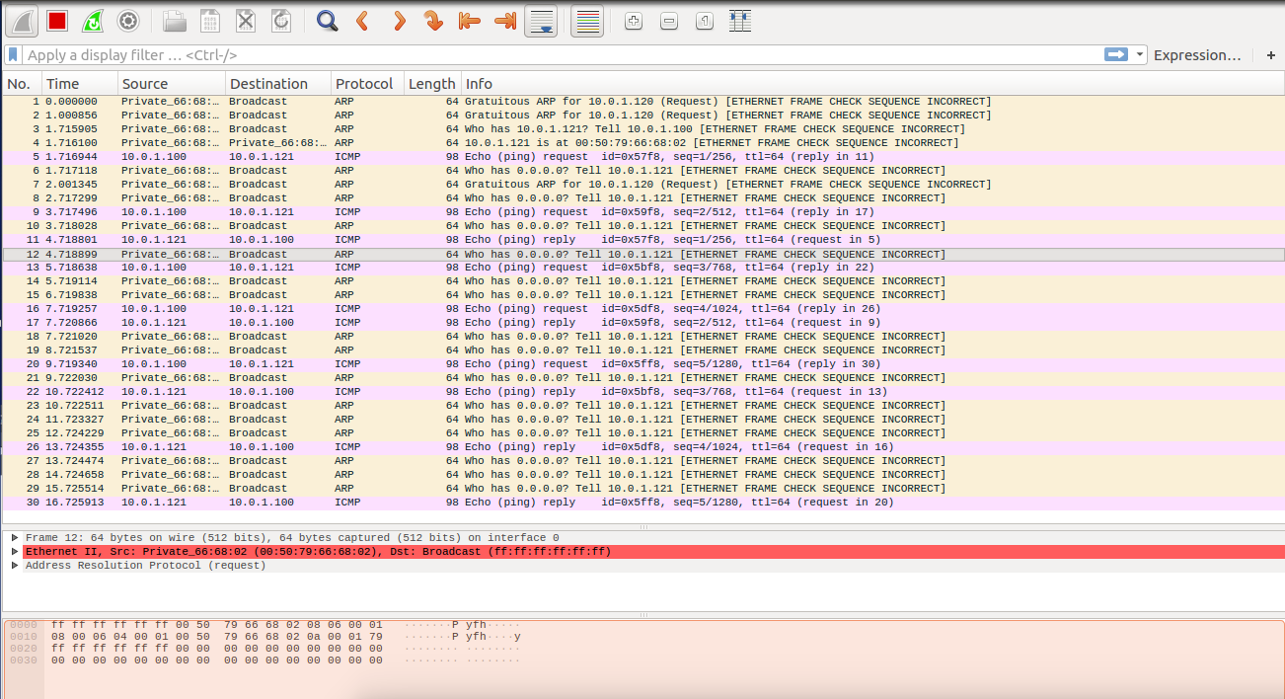

4.6) a)

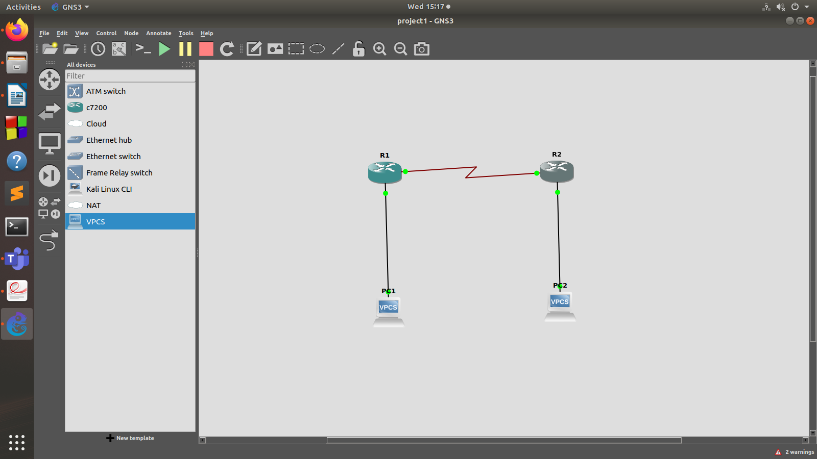

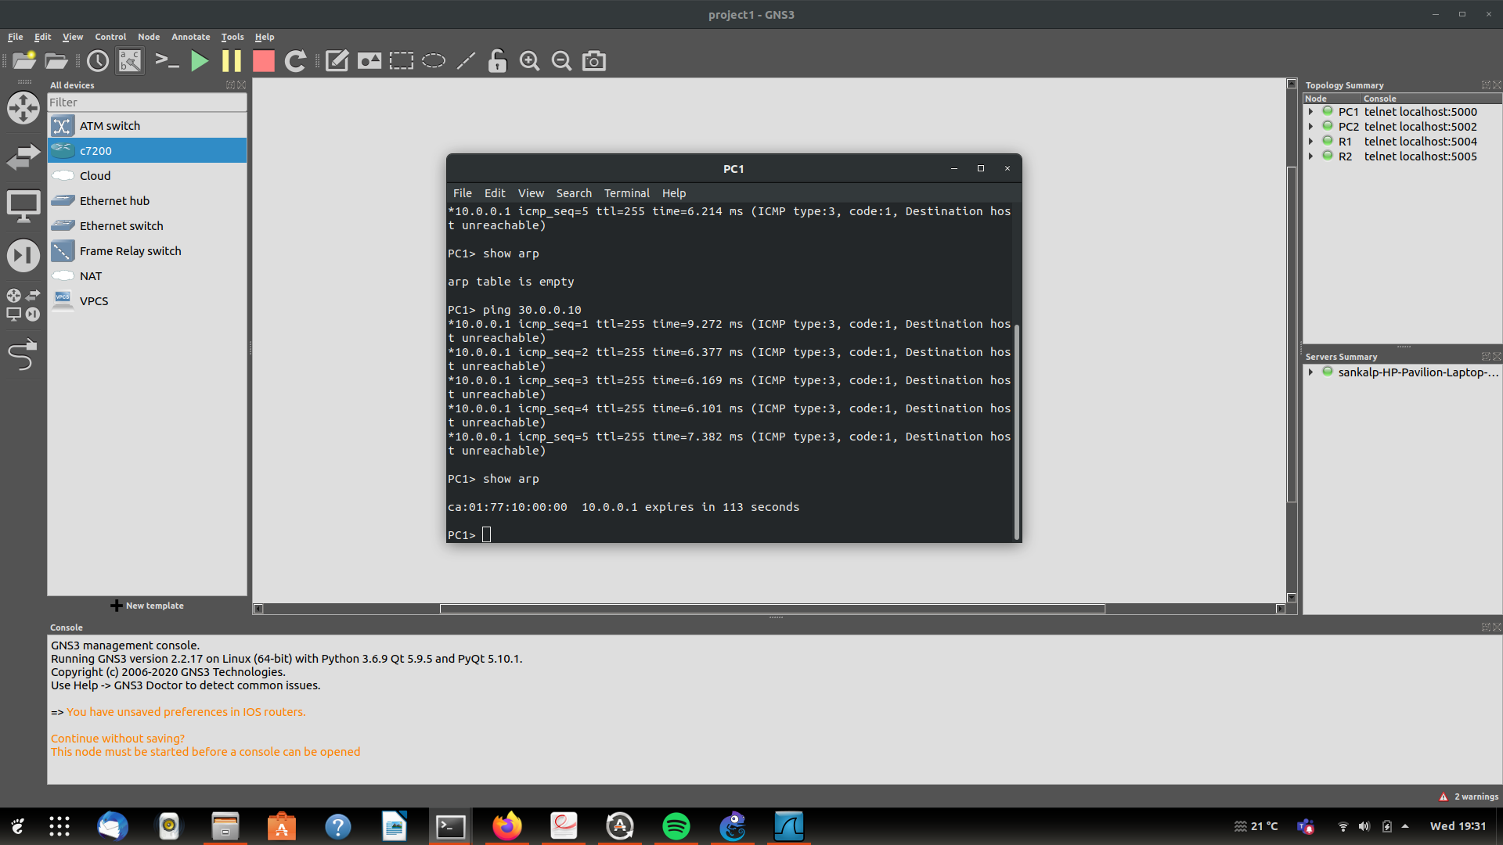

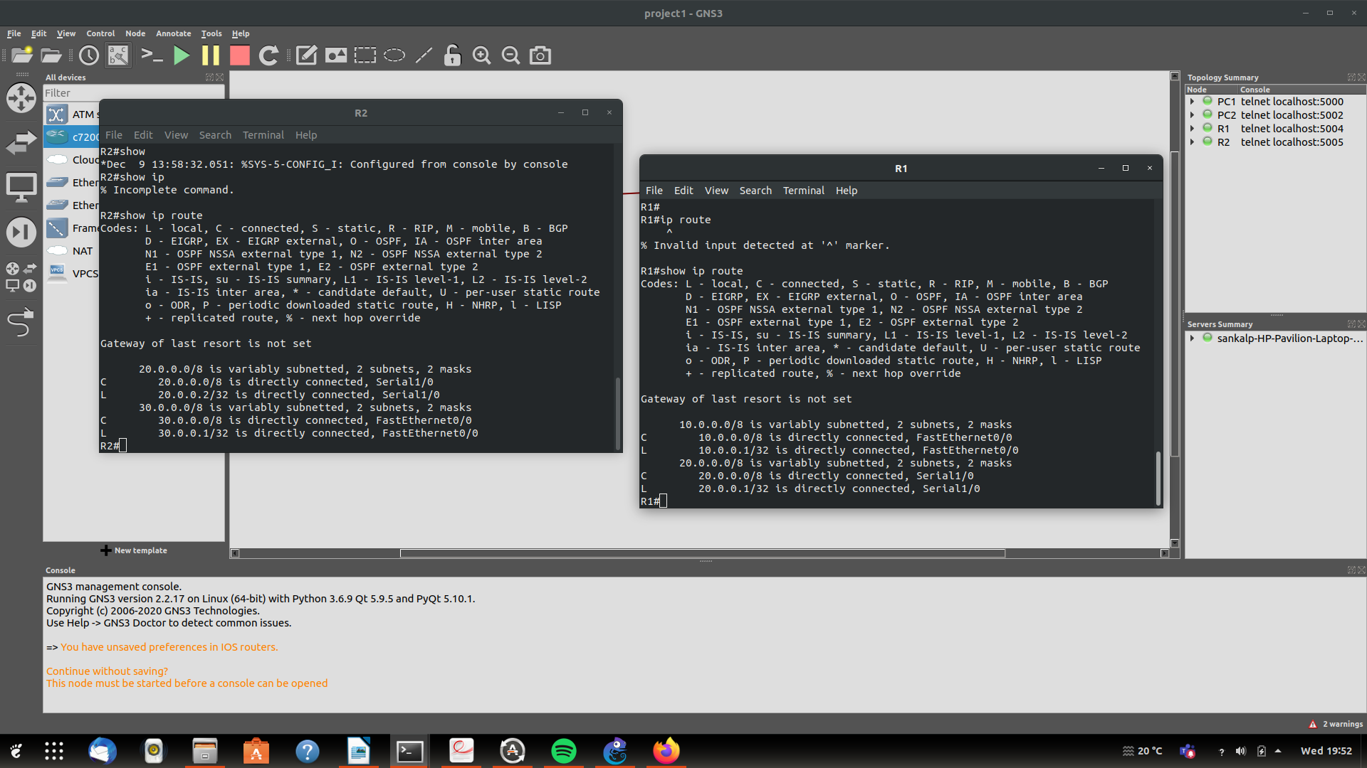

b)

